The dataset ‘Car’ contains 6 features (predictor variables) that describe a car and 1 target variable indicating the overall car evaluation. All variables are categorical.
The following is the detailed description of each variable.
Name of variable | Description | Possible Values
buying | Price of the car | vhigh (very high), high, med (medium), low
maint | Cost of maintenance | vhigh, high, med, low
doors | Number of doors | 2, 3, 4, 5more
persons | Capacity in terms of passengers | 2, 4, more
lug_boot | Size of luggage boot | small, med (medium), big
safety | Estimated safety of the car | low, med, high
evaluation | Overall evaluation of the car | unacc (unacceptable), acc (acceptable), good, vgood (very good)

Instructions:
Load the Car Evaluation dataset into R and answer the following questions using appropriate R commands for summarizing and visualizing categorical data.

Part 1 – Analyzing a Single Categorical Variable
- Create appropriate graph and statistics to summarize the ‘buying’ variable.
Which price category occurs most frequently? Which is least frequent?

Most frequent price category: None (all categories are equally frequent).
Least frequent price category: None (all categories are equally frequent).

The bar chart and the frequency table indicate that the categories of the buying price are evenly distributed. Each of the categories (low, medium, high, and very high) appears exactly 432 times, which is 25% of the data set. Accordingly, there is no category of buying price that is more or less common than the others.
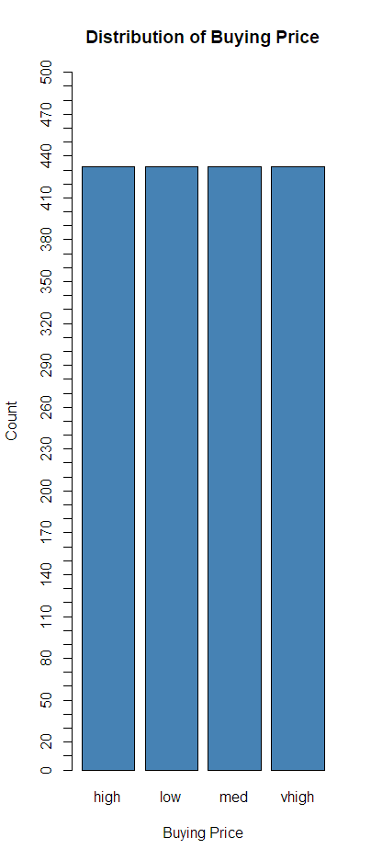

- Create appropriate graph and statistics to summarize the ‘evaluation’ variable.
What proportion of cars is considered acceptable or better?
From the bar chart and frequency distribution, it can be seen that there is an uneven distribution of the categories used in the evaluation of cars. The category ‘unacc’ (unacceptable) is the most frequent, with a total of 1,210 observations, which is about 70% of the total data. On the other hand, ‘good’ and ‘vgood’ (very good) are the least frequent, contributing only about 4% each to the total data. The ‘acc’ (acceptable) category contributes about 22% to the total data.
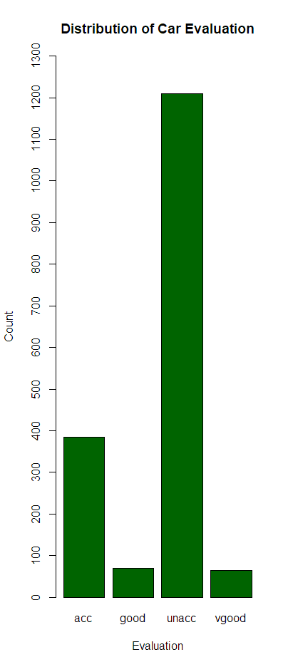

Part 2 – Exploring Relationships Between Two Categorical Variables
- Buying Price vs. Car Class
Create an appropriate graph and statistics to visualize the relationship.
Which buying price category has the highest proportion of cars considered acceptable or better?

The stacked bar chart shows the distribution of car evaluations within each buying price category. Cars with lower buying prices have a higher proportion of acceptable, good, or very good evaluations. Among all categories, the low buying price has the highest proportion of cars considered acceptable or better.
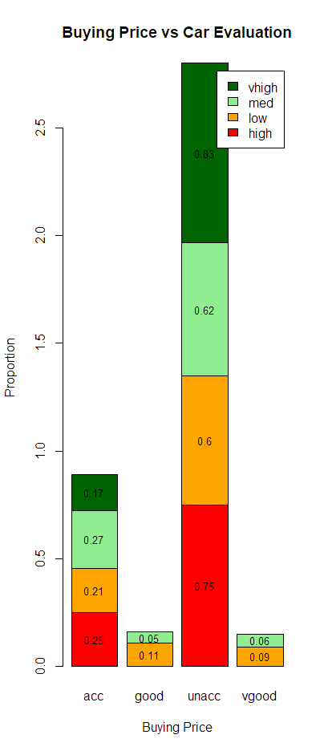
> aggregate(acceptable ~ buying, data = car, mean)
buying acceptable
1 high 0.2500000
2 low 0.4027778
3 med 0.3796296
4 vhigh 0.1666667

- Maintenance Cost vs. Buying Price
Create an appropriate graph and statistics to visualize the relationship.
Describe the relationship between buying price and maintenance cost in one or two sentences.

The contingency table and bar chart indicate the same number (108) for each combination of maintenance cost and buying price.
Thus, there is no visible relationship (association) between the buying price and the maintenance cost in this data set.

